Software Project Management Plan

Version 2.0
04/28/2009

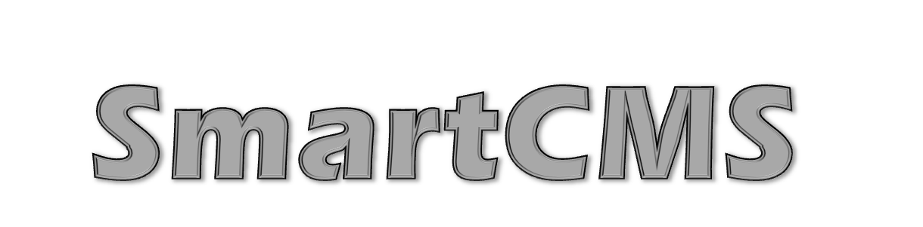
Your Web Design Made Easy

by

John Allen
Johnathan Hasty
Kenneth Musthaler
Matt June
Norman McGarry

HISTORY OF CHANGE
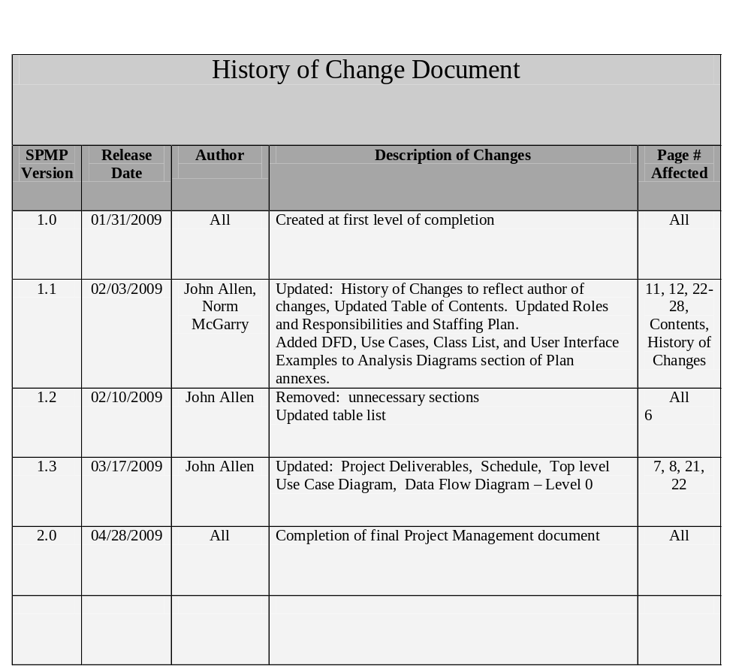
Figure 1: History of Changes Document
Refer to Requirements Control Plan for version change documentation requirements and Evolution of the plan for permitted updates.
PREFACE

This Software Project Management Plan is compliant with the IEEE Standard for Software Management Plans

The following preface and document are written with embedded hyperlinks to navigate you directly to targeted ares of interest located in the body of the Software Project Management Plan (SPMP).

The SPMP for Smart CMS outlines the Scope and the managerial aspects of the project, including a description of deliverables, deadlines and milestones. A tentative schedule along with current objectives are also included in this plan. The main goal of the Smart CMS is to create an easy to use system that will allow people without any knowledge of Hypertext Mark-up Language (HTML) programming to modify their websites. The target audience for this document includes; project team members, project sponsors and project stakeholders such as small to medium businesses that currently have their own Websites.
Contents Index
1. Overview 6
1.1 Project summary 6
1.1.1 Project Scope Statement 6
1.1.2 Assumptions and constraints 6
1.1.3 Project Deliverables 6
1.1.4 Schedule 8
1.1.5 Evolution of the plan 9
2. References 9
3. Definitions 9
4. Project Organization 10
4.1 External Interfaces 10
4.2 Roles and responsibilities 10
5. Managerial Process plans 10
5.1 Start-up plan 10
5.1.1 Estimation plan 10
5.1.2 Staffing plan 10
5.1.3 Resource acquisition plan 11
5.1.4 Project staff training plan 12
5.2 Work plan 12
5.2.1 Work activities 12
5.2.2 Schedule allocation (estimation artefact) 13
5.2.3 Resource allocation 15
5.3 Control plan 15
5.3.1 Requirements control plan 15
5.3.2 Schedule control plan 15
5.3.3 Quality control plan 15
5.3.4 Reporting plan 15
5.4 Risk management plan 15
5.5 Risks 16
5.6 Closeout plan 17
6. Technical process plans 17
6.1 Process model 17
6.2 Methods, tools, and techniques 17
6.3 Infrastructure plan 17
6.4 Product acceptance plan 18
7. Supporting process plans 18
7.1 Configuration management plan 18
7.2 Verification and validation plan 18
7.3 Documentation plan 18
7.4 Quality assurance plan 18
7.5 Reviews and audits 18
7.6 Problem resolution plan 18
7.7 Process improvement plan 18

List of Figures
Figure | Page
Figure 1: History of Changes Document | History of Changes page
Figure 2: Schedule | 9
Figure 3: Definitions | 10
Figure 4: Roles and Responsibilities | 11
Figure 5: Resource Acquisition Chart | 12
Figure 6: Work Activities Chart | 13
Figure 7a: Schedule Allocation | 14
Figure 7b: Schedule Allocation | 15
Figure 8: Risks Document Chart | 18
Figure 9: Level 0 Use Case Diagram | 23
Figure 10: Smart CMS Level 0 DFD | 24
Figure 11: Class List | 28
Figure 12a: Example Web Page | 30
Figure 12b: Example Smart CMS User Interface | 31

Overview

Project summary

Project Scope Statement
It is costly for small businesses to hire web programmers to keep their websites updated. An application should be created to assist small businesses with editing and designing their webpage without this cost and without them needing to learn html.
SmartCMS is a new application developed to create an easy to use system that will allow people without any knowledge of html programming to modify their websites.
Problem statement:
It is costly for small businesses to hire web programmers to keep their websites updated. An application should be created to assist small businesses with editing and designing their webpage without this cost and without them needing to learn html.
Project goals and objectives:
The goal of the Smart CMS is to create an easy to use system that will allow people without any knowledge of html programming to modify their websites.
What program is this code written in?
PHP 5.0 with a MySQL 5.0 database or ASP.NET C# with a MSSQL database. Pros and cons need to be weighed.
List of Needs
Basic Apache server hosting environment or a machine that we can setup apache on with PHP and MySQL enabled, or a Windows Server for development using ASP.NET and MSSQL.
Project non-goals:
The prototype version of Smart CMS will not:
1. Create templates for the user.
2. Submitted changes are not reversible.
3. Not consistent with error or grammar checking/correction.
Project Requirements:
The Smart CMS will have a secure login. Multiple user levels will control what the users are able to do. The user will have options to load or create templates, edit or add pages, view or submit the finished product.

Assumptions and constraints
Web page to be edited by Smart CMS contains template syntax compatible markers for dynamic areas.

Project Deliverables
- Project Scope Document
- Abbreviated Project Plan
- Abbreviated System Requirements Document
- Software Design Definitions Document
- Final Prototype
- Final Prototype Software
- Testing Modules (if any)
- Project Report
- Project Presentation
Refer to Methods, tools, and techniques for system environment and design tools.

Schedule
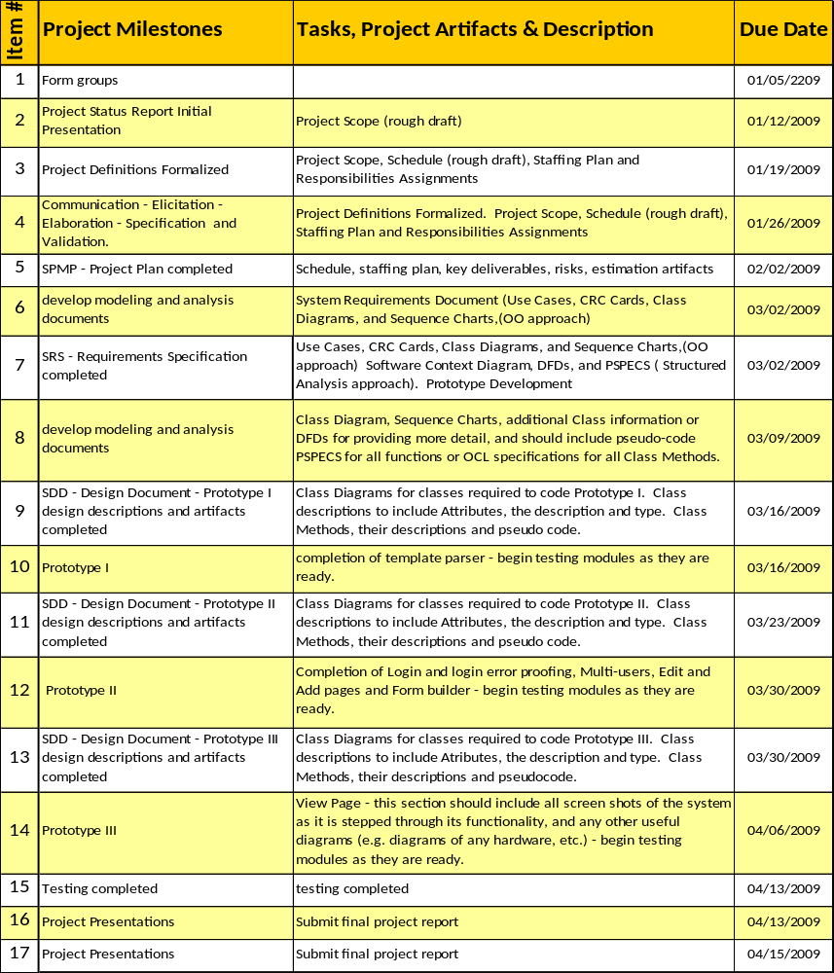
Figure 2: Schedule

Evolution of the plan
The SPMP shall have scheduled and unscheduled updates.
Both scheduled and unscheduled updates will be documented in the History of Changes chart, Figure 1: History of Changes Document, SPMP version, release date, previous version, description of changes and page number affected.

References
- Roger S. Pressman, Software Engineering: A Practitioner’s Approach, 6/e,Mc Graw Hill, 2005.
- IEEE_Software_management_plan_guideline_1998.pdf.
- Raj, Aditya, Certified Scrum Master: Agile Project Management with Scrum online video presentation, http://www.slideshare.net/aditya.internet/agile-project-management-with-scrum, 2007.
- Wikipedia, the free encyclopedia (Redirected from Agile Project Management): Agile software development, http://en.wikipedia.org/wiki/Agile_Project_Management

Definitions
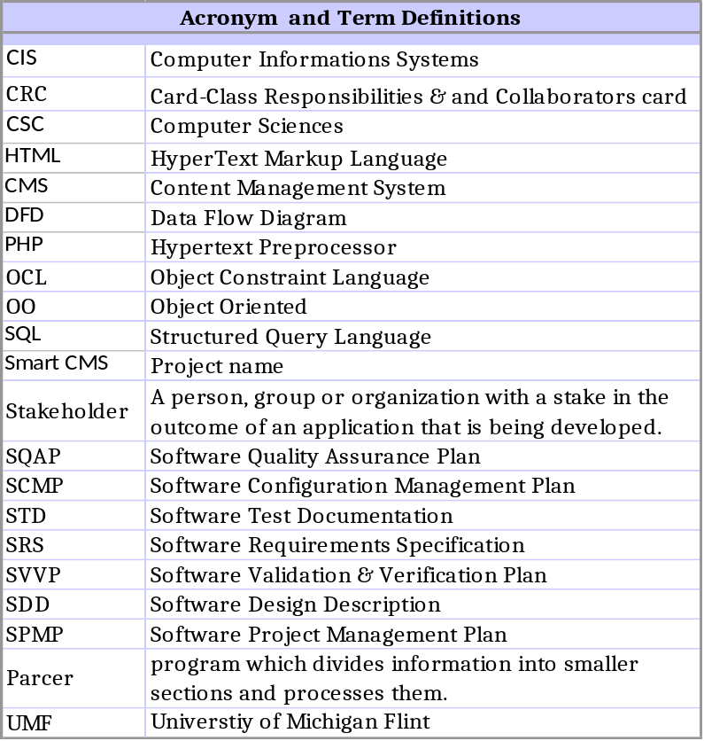\
Figure 3: Acronym and Term Definitions

Project Organization

External Interfaces
The external interfaces for the project would be Dr. Michael Farmer who is the reviewer and grader of this project.

Roles and responsibilities
Role | Description | Person
Project Manager | Responsible for project deliverables, risk and project management, and overall guidance and participation. | John Allen
Quality Assurance Manager | Responsible to ensure that quality-control measures are strictly adhered to throughout the project life. | Johnathan Hasty
Technical Architect | Recommends the development methodologies and frameworks of the project, and is responsible for ensuring the project is adequately designed and documented. | Kenneth Musthaler
Project Director & Technical Advisor | Responsible for the technical direction of the project process and mentoring the CSC-382 and CSC-383 weak to take this project from beginning to end. | Matt June
Software Design Engineer | Responsible for software design, development and documentation. | Norman McGarry
Figure 4: Roles and Responsibilities

Refer to Staffing Plan for role skill requirements.

Managerial Process plans

Start-up plan

Estimation plan
The project will follow and adhere to the Schedule Allocation. All milestones will be met and deadlines in the Schedule will be met. Risks will be monitored using the Risk Document Chart.

Project completion is estimated and deliverables will be delivered no later the April 20, 2009.

Staffing plan
The project team will consist of five (5) staff members.

- Application Architect: Responsible for software design, development and documentation.

Skills required include but not limited to PHP Programming, HTML Programming, and SQL Programming and software design.

- Project Manager: Responsible for project deliverables, risk and project management, and overall guidance and participation.

Skill sets required include but not limited to technical skills required to develop software, the ability to anticipate, attend to details, and to influence people.

- Quality Assurance Manager: Responsible to ensure that quality-control measures are strictly adhered to throughout the project life.

Skill sets required include but not limited to strong mathematical skills and critical thinking skills required to analyze data and reports, determine the root cause of quality problems, and envision effective solutions.

- Technical Architect: Recommends the development methodologies and frameworks of the project, and is responsible for ensuring the project is adequately designed and documented.

Skill sets required include but not limited to the technical writing skills needed to ensure sure all documentation is complete and correct, knowledge of project development methodologies and frameworks.

- Project Director: Responsible for the technical direction of the project process and mentoring the CSC-382 and CSC-383 weak to take this project from beginning to end.

Skill sets required include but not limited to strategic analysis, strategy development and implementation concepts, principles and techniques, knowledge of project management methodologies and tools, a prior successful completion of CSC-382 and CSC-383.

Refer to Figure 4: Roles and Responsibilities for assignments of these roles.

Resource acquisition plan
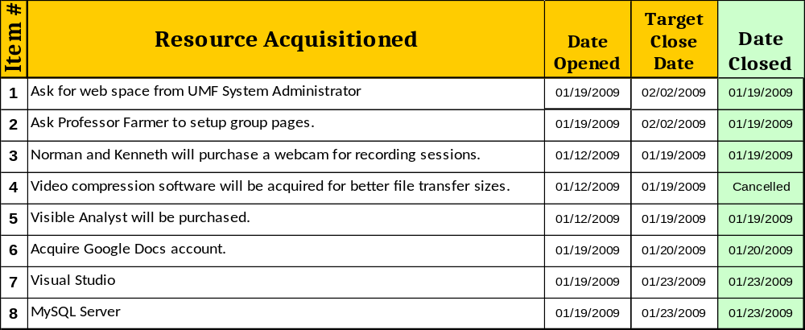
Figure 5: Resource Acquisition Chart

Project staff training plan
All members except Matthew are current taking CSC382 simultaneously with CIS420 in order to gain knowledge necessary for completing this project. Any future training needs to complete this project will be assessed and remedied.

Work plan

Work activities
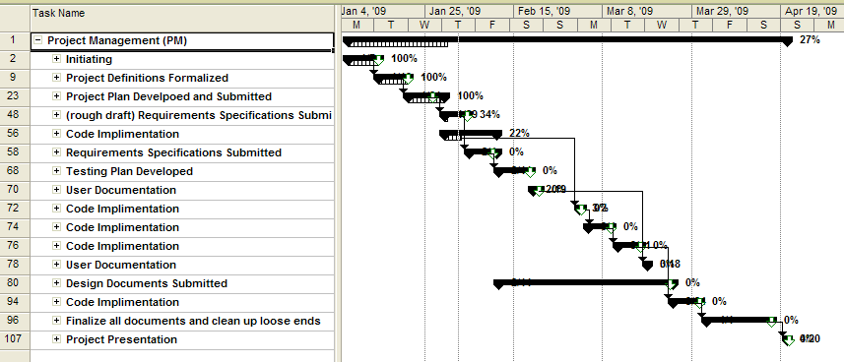

Figure 6: Work Activities Chart

Refer to Figure 6: Schedule Allocation below for more detailed Work Activities.

Schedule allocation (estimation artefact)
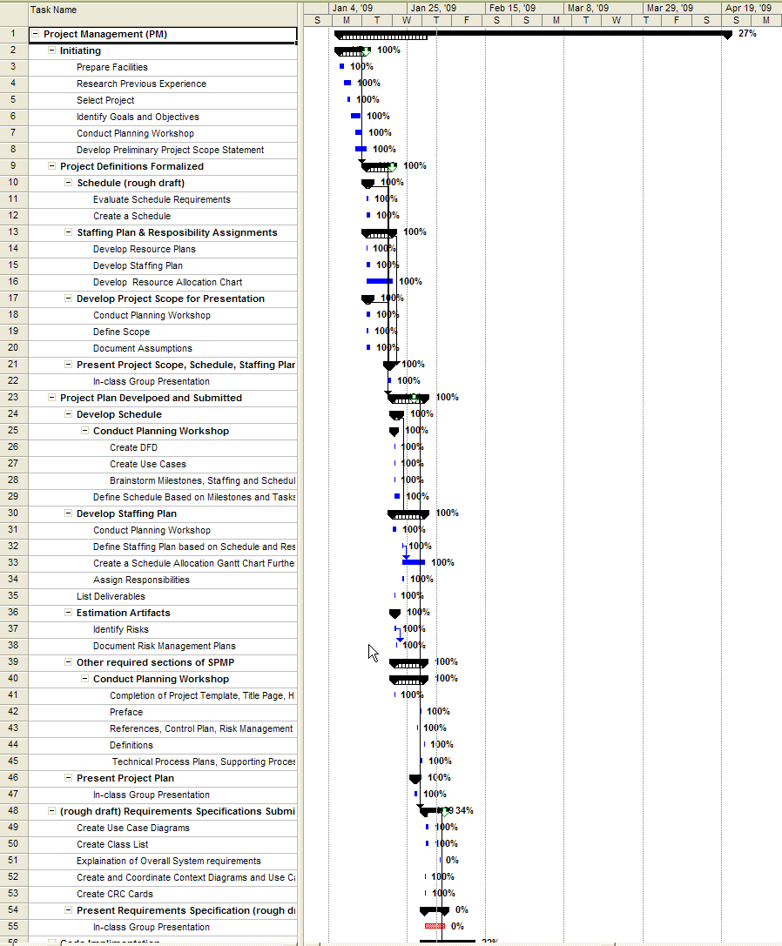
Figure 7a: Schedule Allocation
Schedule allocation (continued)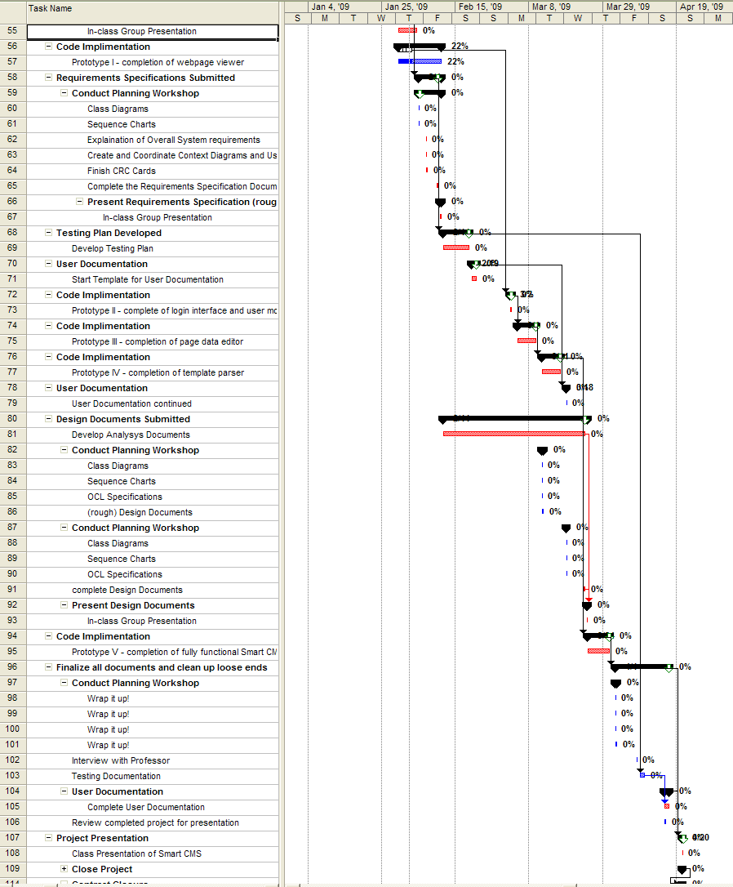

Figure 7b: Schedule Allocation
Refer to Work Plan for list of Milestones. The Schedule Allocation plan will also be used as part of the Quality Control Plan.

Resource allocation
Refer to Roles and Responsibilities
In addition, the team meets every Wednesday from 6:30PM to 10PM.

Control plan

Requirements control plan
The Software Requirements Specs, Software Design Specs, and the Schedule Allocation with the Schedule will be used as the primary control tools for this project.

Any requested changes will require team approval. All changes will be documented in History of Changes. The beginning, creation, version of this document is Version 1.0. All changes made in development will increment the value in the decimal place, i.e. from Version 1.0 to Version 1.1, Version 1.2 and so on. Before new copies are populated or if 9 incremental versions have been reached, all incremental changes will be included in a full version change, i.e. Version 1.2 to Version 2.0. All version changes are recorded in the History of Changes.

Schedule control plan
We will carefully track our progress through out the project to ensure that we will be reaching milestones when intended. At each group and class meeting, we will assess our progress towards the next milestone and if we are found to be falling behind the group will discuss and implement corrective measures to get us back on schedule to include working extra hours or contracting work.

Quality control plan
Following each development cycle the Quality Assurance Manager and the Project Manager (personnel assigned to quality control can be found here: Roles and Responsibilities) will perform a review to determine whether or not the requirements that were supposed to be implemented that development cycle were in fact implemented and also to ensure that the software lives up to industry performance standards. If requirements intended to be implemented during a development cycle are found to be left out, the Quality Assurance Manager will need to report this to the group ASAP.

Reporting plan
We will have a team progress report with updates during each class meeting time. The team also will meet weekly in four hour sessions. Our means of communications are in the form of email, cell phone, and blackboard.

(810) 625-9894 - John Allen - johnal@umflint.edu
(989) 366-1672 - John Hasty - johnathh@umflint.edu
(810) 441-5894 - Ken Musthaler - kmusthal@umflint.edu
(810) 653-0879 - Matt June - mjune@umflint.edu
(248) 421-5884 - Norm McGarry - nmcgarry@umflint.edu

Risk management plan
Throughout development, all risks will be tracked. At each ‘Sprint cycle’, described in the Technical Process Plans section in the Process Model subsection of this document, or with any change to the schedule or schedule allocation, risks will be reassessed to determine the current level of threat that they pose to the project and at each milestone any risks we have passed will be removed.

Refer to Risk Document Chart for Risks

Risks
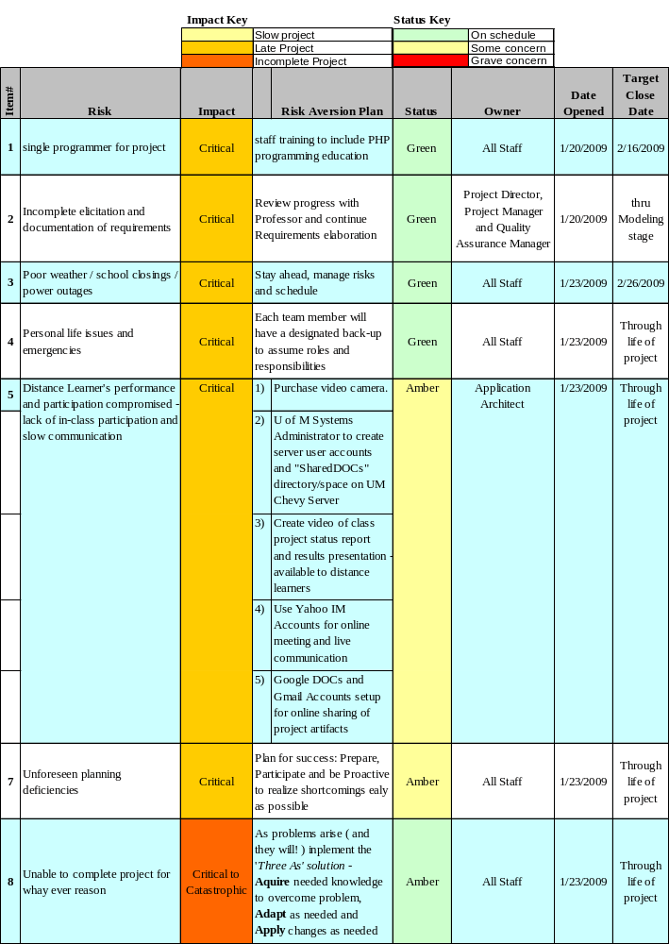
Figure 8: Risks Document Chart
Refer to Risk Management Plan for risk assessment intervals.

Closeout plan
After final presentation and grading, the team will meet to out-process and review information with the professor.

Technical process plans

Process model
The model to be used will be Agile: with Scrum.

From Wikipedia, “Agile software development is a group of software development methodologies that are based on similar principles. Agile methodologies generally promote a project management process that encourages frequent inspection and adaptation, a leadership philosophy that encourages teamwork, self-organization and accountability, a set of engineering best practices that allow for rapid delivery of high-quality software, and a business approach that aligns development with customer needs and company goals.”

From Aditya Raj’s “Agile Project Management with Scrum” online video presentation, “[Scrum is a common sense approach toward software development. The scrum approach is fast and flexible and, most importantly, is commitment oriented. The approach is based on clarity, inspection and adaptation.

A primary tool of scrum is frequent meetings. Tasks are divided into “Sprint Cycles”. The first Sprint Cycle meeting is the planning meeting and is divided in two, have focuses on what to do and the second half on how to do it. Following Scrum meetings are frequent and short with specific questions answered by each member of the team like: what they did last meeting, what they plan to do until the next meeting, and what articles are in the way. Scrum review and retrospective meetings are held after every Sprint cycle.

Our team’s Sprint meetings will be our weekly meetings on Wednesdays. Our frequent meetings will be executed using scheduled email communications, conference calling or an Instant Messaging format/environment to speed communications further. Our class meetings will be our review and retrospective meetings.

This type of Agile Project Management with Scrum will allow our team to stay on track and produce faster results with less error and confusion.]”

Methods, tools, and techniques
The computing system environment is optimized for 800x600 resolution or better web browser viewing. The design tools used will be Microsoft Visual Studio and SQL Server. Test modules will be developed to test classes as they are prototyped.

Refer to Scope For product languages.

Infrastructure plan
SmartCMS is compatible with Microsoft Internet Explorer 6.0+ and any newer versions of other web browsers.

Product acceptance plan
Fulfilment of all agreed upon requirements will be necessary for the acquirer to accept delivery of the product. Prior to delivery we will demonstrate the SmartCMS product to Dr. Farmer using already existing code modified with the template syntax.

Supporting process plans

Configuration management plan
Configuration management isn’t quite applicable to our project. If necessary in the future, we will develop a configuration management plan.

Verification and validation plan
Our verification processes are based on our techniques of traceability, milestone reviews, progress reviews, peer reviews, prototyping, simulation, and modelling.

In order to ensure completion of functional requirements we will document the requirements and the class or classes that provide those requirements.

Documentation plan
Software documentation for Smart CMS and Smart CMS testing software will be generated by PHP Documents, a functional tool of the PHP environment.

Quality assurance plan
During each cycle we will determine a set of requirements from the requirements document that are to be satisfied during that cycle. Following completion of the cycle we will review what has been produced to determine if all requirements that were expected to be fulfilled are present. If it is determined that a requirement was not fulfilled then the team will determine if changes to already existing products will be necessary to meet the requirement or if it can be pushed to another development cycle. The Design Document will be used to communicate and check design requirements.

Reviews and audits
We will conduct weekly reviews to determine quality and throughput of documentation including requirements, design, testing, and software development. We will present a progress report to Dr. Farmer detailing our progress made since the last meeting and a list of any problems we encountered.

Problem resolution plan
During the week team members should compile a list of problems and the corrective measures, if any, taken to resolve the problems. At the weekly team meeting team members will report the problems they encountered, which they were able to resolve and what they were not able to resolve, and the corrective measures they were able to take for the problems they did resolve. The team will discuss possible solutions for the unresolved issues and determine the best solution.

Process improvement plan
At each team review team members will report any problems they have encountered since the last meeting. The team will try to determine the root cause of these problems and determine a solution to prevent the problem from reoccurring.

